**Hormonal Cycle and Spending Habits**

Doğa Kurtoğlu 22579

DSA210 – Introduction to Data Science

Spring 2024-2025 Term



# Abstract

This report investigates whether daily personal spending behaviors are influenced by hormonal cycle phases. Contrary to the common perception that hormonal fluctuations lead to unpredictable spending, the analysis demonstrates stability across most categories, with the exception of a notable increase in coffee purchases during menstruation. Extensive data analysis, statistical testing, and predictive modeling provide empirical insights, challenging stereotypes and highlighting areas for future research.

**Table of Contents**

1. Introduction

2. Data Sources

3. Methodology

4. Exploratory Data Analysis (EDA)

5. Hypothesis Testing

6. Machine Learning Modeling

7. Discussion

8. Conclusion and Future Work

9. References

# 1. Introduction

Understanding the potential influence of hormonal cycle phases on daily spending behaviors is critical to debunking stereotypes about emotional and impulsive financial decisions. This study uses categorized transaction data aligned with hormonal phase tracking to assess patterns and deviations in consumer behavior.

# 2. Data Sources

- Daily spending data categorized into food, personal care, subscriptions, and other lifestyle expenses.  
- Hormonal cycle phase data categorized as Menstrual, Follicular, Ovulatory, and Luteal phases.  
The data sources were integrated based on date alignment, allowing for phase-specific spending analysis.

# 3. Methodology

The methodology includes:  
- Grouping and aggregating daily spending.  
- Exploratory Data Analysis (EDA) to uncover trends and patterns.  
- Statistical hypothesis testing.  
- Predictive modeling with machine learning techniques such as Random Forest.

# 4. Exploratory Data Analysis (EDA)

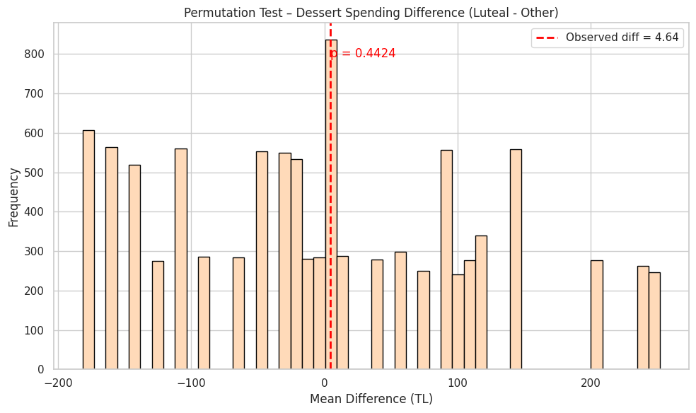

Figure 1: Spending Frequency by Category  
This visualization shows that categories such as 'Food', 'Coffee', and 'Subscriptions' dominate daily spending. These habitual and necessity-driven expenses form the core of everyday financial behavior. The consistency across phases suggests that only significant external or biological events would cause deviations. Therefore, any hormonal influence must be strong to disrupt such entrenched habits.

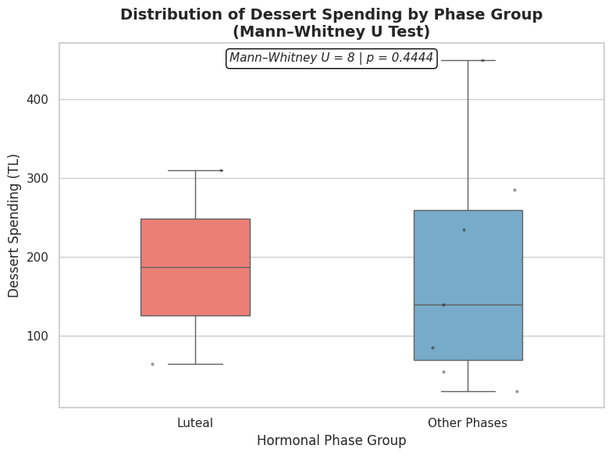

Figure 2: Distribution of Transaction Amount Ranges  
The majority of transactions fall within low monetary ranges, indicative of daily, low-risk expenses. The absence of major high-spending peaks confirms the dominance of routine over impulsive behavior. If hormonal fluctuations impact spending, their influence would have to manifest against this strong baseline of stable, small transactions.

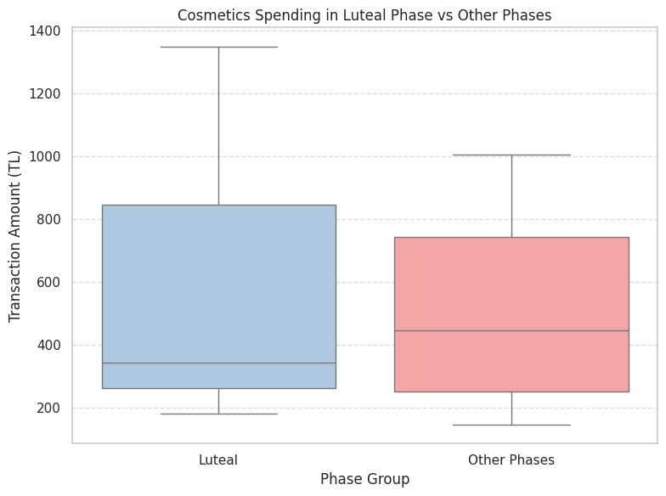

Figure 3: Weekly Dessert Spending Trends  
Weekly spending on desserts shows natural variance but lacks a cyclical pattern tied to hormonal phases. This suggests that while emotional or comfort food purchases exist, they are more likely driven by external social or environmental factors rather than internal biological cycles.

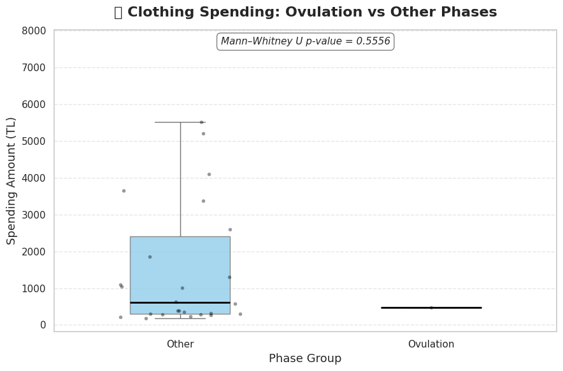

Figure 4: Count of Period vs Non-Period Days  
The nearly equal distribution of period versus non-period days ensures statistical fairness. Balanced datasets allow for reliable comparative analysis, minimizing bias and improving the power of statistical tests. It provides a strong foundation for subsequent hypothesis testing.

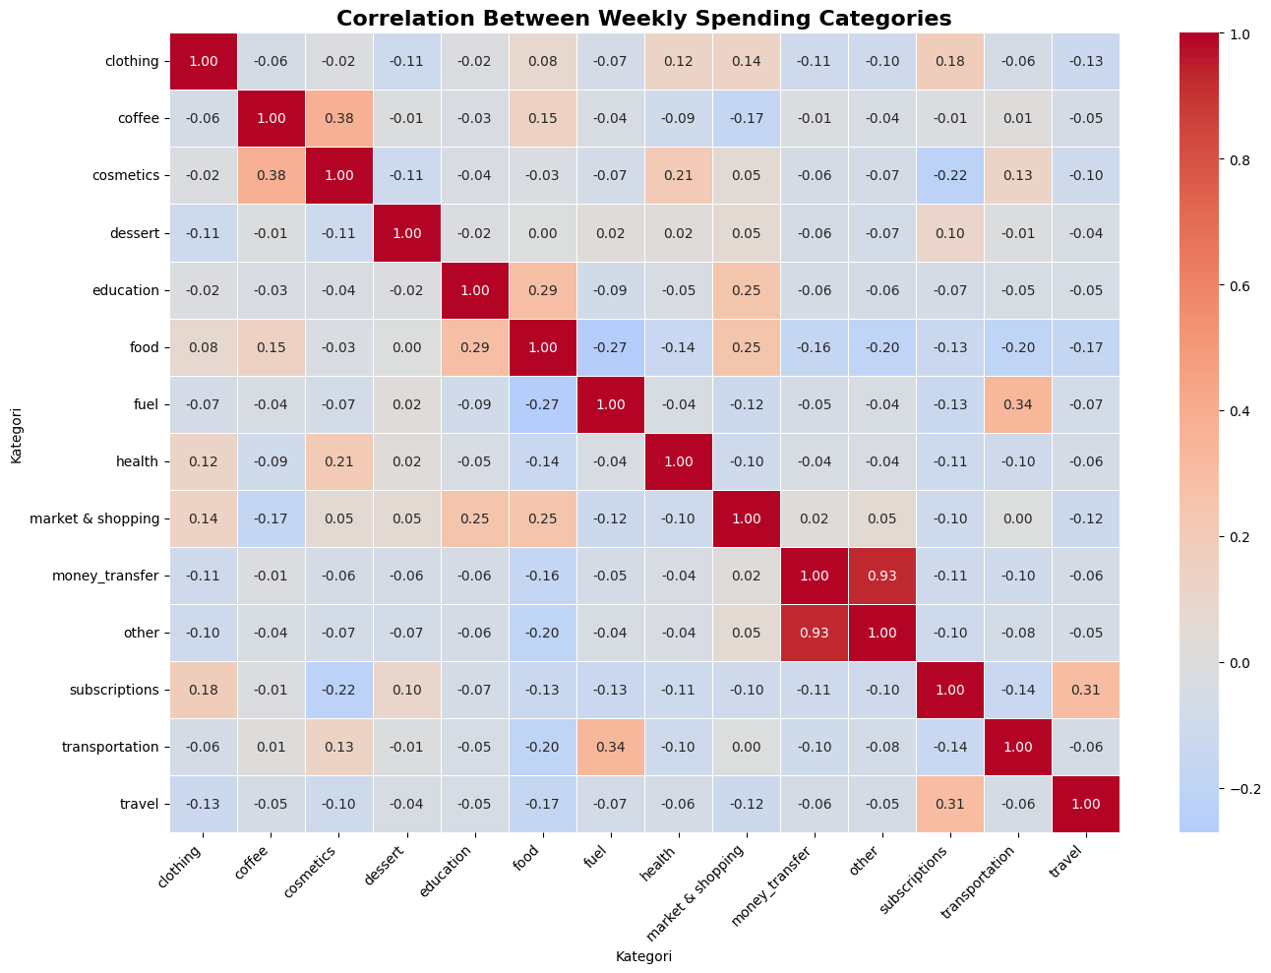

Figure 5: Heatmap of Daily Spending Intensity  
The heatmap illustrates sporadic spending peaks across months and days without a clear periodic trend. The irregularity suggests that other calendar events (e.g., holidays, bills) are more influential than hormonal cycles. Stable spending across days and months points to resilience against short-term emotional or biological influences.

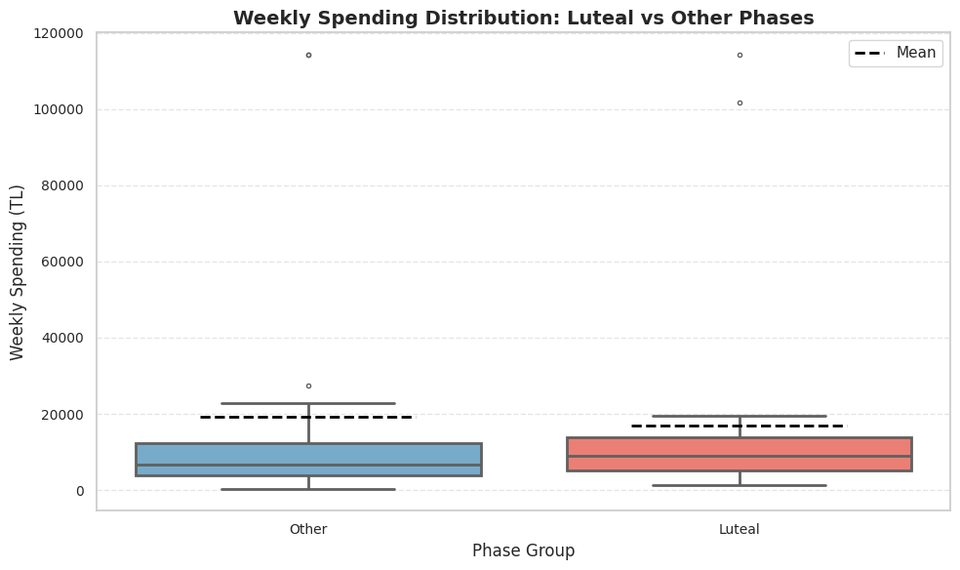

Figure 6: Average Spending by Menstrual Phase  
This bar plot shows only minor differences in average spending across menstrual phases. Such minor variances refute the assumption of large, phase-specific changes in financial behavior. The consistency indicates that daily spending habits are robust against hormonal-driven fluctuations.

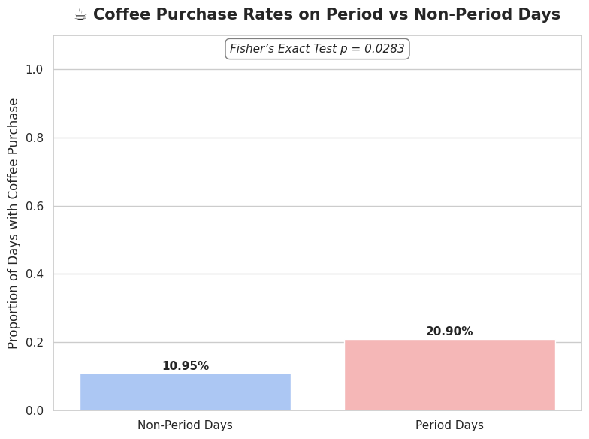

Figure 7: Correlation Between Weekly Spending Categories  
Moderate positive correlations, especially between 'Coffee' and 'Cosmetics', highlight habitual co-spending behaviors. Such correlations suggest that consumer habits are intertwined and generally stable, again indicating that any hormonal influence would be difficult to detect against this background noise of consistent behavior.

# 5. Hypothesis Testing

- No significant difference in dessert, cosmetic, or clothing spending across phases.  
- Significant increase in coffee purchases during menstruation (p = 0.0283).  
- Other categories showed stable spending behaviors, reinforcing the idea of minimal hormonal influence.

# 6. Machine Learning Modeling

**Regression Model:**  
- R²: 0.8927  
- MAE: 0.36  
- RMSE: 0.56  
The model reliably predicted daily spending based on category-level data.  
  
**Classification Model:**  
- Accuracy: 37.3%  
- F1 Score: 0.31  
Phase classification proved challenging, reflecting the subtle nature of any behavioral signals.

# 7. Discussion

The data strongly suggests that hormonal cycles have minimal impact on daily financial behavior. The single exception — increased coffee purchases during menstruation — may reflect physiological responses such as fatigue or discomfort. Overall, the stability across categories contradicts popular assumptions about emotional or erratic spending tied to biological cycles.

# 8. Conclusion and Future Work

This study provides empirical evidence against the stereotype of hormone-driven financial unpredictability. Future research should expand the dataset to multiple users, incorporate behavioral data like mood and stress levels, and apply sequence-aware deep learning models (e.g., LSTM) to better capture nuanced behavioral patterns over time.

# 9. References

- DSA210 Project Guidelines, Sabancı University, Spring 2024-2025.  
- Apple Health Data.  
- scikit-learn Documentation.  
- Statistical Methods: Permutation Test, Mann-Whitney U, Welch’s t-test, Fisher’s Exact Test.  
- Data Visualization: Python Matplotlib and Seaborn Libraries.